**About**

Macrocycles, defined as rings of at least 12 heavy atoms, have garnered significant attention across various scientific fields, including drug discovery [1]. Their appeal lies in their capacity to provide functional diversity and stereochemical complexity. This distinctive structural attribute empowers macrocycles to bind with high affinity and selectivity to ‘difficult to drug’ targets that are challenging to modulate with traditional small-molecule drugs or adhere to the Rule of Five (Ro5) [2-4]. Despite their size, macrocycles may still possess sufficient cell permeability and bioavailability, rendering them promising candidates for oral administration. While macrocyclic drugs were historically derived from natural sources, there is a growing inclination towards the de novo design of macrocycles as approved pharmaceuticals.[1] The rational design of potent, cell-permeable, orally available macrocyclic drugs poses numerous challenges, particularly concerning synthesis and conformational prediction [5-7].

The process of passive cell permeability involves several complex steps, including desolvation when the drug transitions from the extracellular aqueous environment to interacting with the negatively charged phospholipid head groups before penetrating the hydrophobic membrane interior. These steps are then reversed as the drug moves into the cytosol. Each of these processes is influenced to varying degrees by the molecular properties of the drug. For example, the compound's polarity, represented by its 3D polar surface area (PSA), significantly impacts the desolvation kinetics. The compound's size, approximated by the radius of gyration (Rgyr), affects the rate of diffusion across the membrane, while its lipophilicity (cLogP or cLogD) is crucial for the thermodynamics of permeation [6].

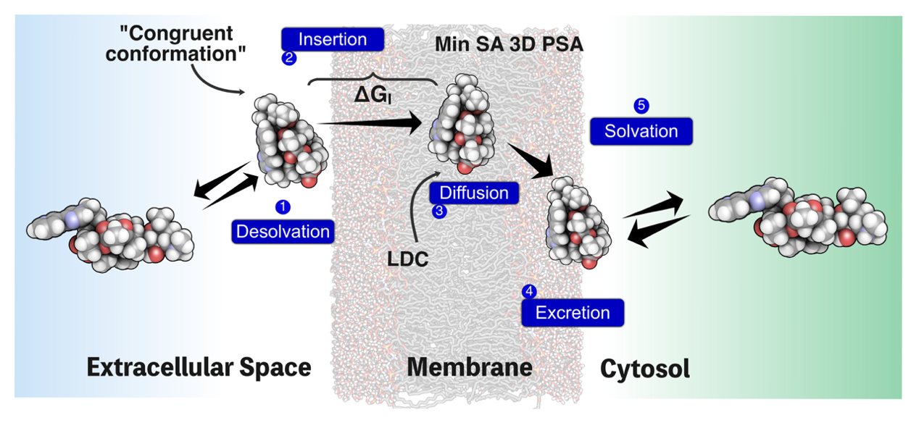

**Figure 1.** Schematic representation of passive permeability of telithrothromycin is shown[8].

**Curation of Cell Permeability Data for Predictive Modeling**

Quantitative structure-permeability relationship (QSPR) methods are commonly used to model permeability in drug discovery. These methods rely on statistical relationships derived from experimental permeability data and physicochemical descriptors, such as PSA, Rgyr, and cLogP/D, calculated for a set of compounds used for training [6-9]. Alternatively, some models are developed based directly on the physical processes involved. Physics-based models have provided a deeper understanding of how macrocycles can cross cell membranes.[10]

To facilitate the accurate and efficient computational prediction of permeability, it is crucial to collect and curate experimental data with structural information, making it accessible to the scientific community. Our initiative draws inspiration from the recent work of Li J et al., [11] who created [CycPeptMPDB](http://cycpeptmpdb.com), a comprehensive database focusing on membrane permeability for cyclic peptides, comprising over 7000 cyclic peptides from various publications. However, Li J's database is confined to cyclic peptides and does not include any nonpeptidic macrocycles. In our web server, we have established a cell permeability database specifically for nonpeptidic macrocycles, serving as a comprehensive online resource for macrocycles with cell permeability. This database contains curated macrocycles (both semi-peptide and non-peptide) sourced from scientific literature, patents, and various bioactivity data repositories. It includes structures and cell permeability data obtained from different assays, endpoints, and molecular features for 4602 unique macrocycles. These data are readily accessible and downloadable through the web server (http://swemacrocycle.com) for further modeling purposes. The diversity of the dataset based on fingerprinting is showcased using the TMAP, with various assays and features highlighted.

Macrocyclic Compounds 3 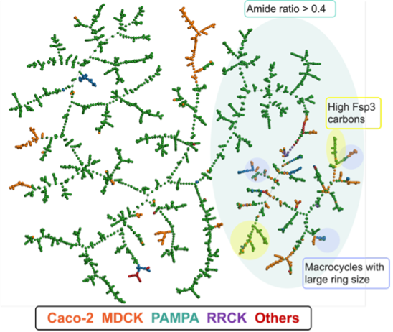

**Figure 2.** Left Panel:The workflow of the cell permeability database for nonpeptidic macrocycles. Structures and permeability data were retrieved from the literature, patents, and scientific databases, followed by manual curation. The webserver provides readily downloadable datasets for various cell permeability assays and endpoints. Additionally, the webserver incorporates analyses based on various physicochemical descriptors. Right Panel: Diversity of non-peptidic macrocyclic dataset(n=5646) is visualized using TMAP tool. Various assays and features are highlighted.

**Reference**

1. Garcia Jimenez, D.; Poongavanam, V.; Kihlberg, J. Macrocycles in drug discovery─ learning from the past for the future. *Journal of Medicinal Chemistry* **2023**, 66 (8), 5377-5396.
2. Giordanetto, F.; Kihlberg, J. Macrocyclic drugs and clinical candidates: what can medicinal chemists learn from their properties? *Journal of medicinal chemistry* **2014**, 57 (2), 278-295.
3. Lipinski, C. A.; Lombardo, F.; Dominy, B. W.; Feeney, P. J. Experimental and computational approaches to estimate solubility and permeability in drug discovery and development settings. *Advanced drug delivery reviews* **2012**, 64, 4-17.
4. Veber, D. F.; Johnson, S. R.; Cheng, H.-Y.; Smith, B. R.; Ward, K. W.; Kopple, K. D. Molecular properties that influence the oral bioavailability of drug candidates. *Journal of medicinal chemistry* **2002**, 45 (12), 2615-2623.
5. Sethio, D.; Poongavanam, V.; Xiong, R.; Tyagi, M.; Duy Vo, D.; Lindh, R.; Kihlberg, J. Simulation reveals the chameleonic behavior of macrocycles. *Journal of Chemical Information and Modeling* **2022**, 63 (1), 138-146.
6. Over, B.; Matsson, P.; Tyrchan, C.; Artursson, P.; Doak, B. C.; Foley, M. A.; Hilgendorf, C.; Johnston, S. E.; Lee IV, M. D.; Lewis, R. J. Structural and conformational determinants of macrocycle cell permeability. *Nature Chemical Biology* **2016**, 12 (12), 1065-1074.
7. Rossi Sebastiano, M.; Doak, B. C.; Backlund, M.; Poongavanam, V.; Over, B. r.; Ermondi, G.; Caron, G.; Matsson, P. r.; Kihlberg, J. Impact of dynamically exposed polarity on permeability and solubility of chameleonic drugs beyond the rule of 5. *Journal of medicinal chemistry* **2018**, 61 (9), 4189-4202.
8. Poongavanam, V.; Wieske, L. H.; Peintner, S.; Erdélyi, M.; Kihlberg, J. Molecular chameleons in drug discovery. *Nature Reviews Chemistry* **2024**, 8 (1), 45-60.
9. Poongavanam, V.; Atilaw, Y.; Ye, S.; Wieske, L. H.; Erdelyi, M.; Ermondi, G.; Caron, G.; Kihlberg, J. Predicting the permeability of macrocycles from conformational sampling–limitations of molecular flexibility. *Journal of Pharmaceutical Sciences* **2021**, 110 (1), 301-313.
10. Rezai, T.; Bock, J. E.; Zhou, M. V.; Kalyanaraman, C.; Lokey, R. S.; Jacobson, M. P. Conformational flexibility, internal hydrogen bonding, and passive membrane permeability: successful in silico prediction of the relative permeabilities of cyclic peptides. *Journal of the American Chemical Society* **2006**, 128 (43), 14073-14080.
11. Li, J.; Yanagisawa, K.; Sugita, M.; Fujie, T.; Ohue, M.; Akiyama, Y. CycPeptMPDB: A comprehensive database of membrane permeability of cyclic peptides. *Journal of Chemical Information and Modeling* **2023**, 63 (7), 2240-2250.